CONNECTION BETWEEN FORCES AND POTENTIAL ENERGY

We have been analyzing two types of Conservative forces (these are forces for which the work done by forces only depends on the start and end points and not on the path taken) – Gravity and Spring. Both of these have a potential energy associated with them. Lets look at the connection between the forces and the associated potential energy function.

Force Zero –
Equilibrium Point
U

Unstable Equilibrium points

x
Stable Equilibrium Points

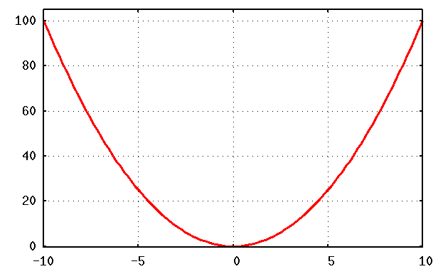
Sometimes, the potential energy function is depicted graphically. A lot of information about the associated force may be found from it. If the system only has the associated conservative force acting on it, we may be able to predict a lot about the behavior of the system. Lets start with a simple system of a mass on a horizontal spring (no friction). Its Potential energy is depicted below.
Potential Energy in J
X in m
Slope(derivative) is negative and the force is positive i.e pointing to the right.
Value of the slope gives the magnitude of the force.
Slope(derivative) is positive and the force is negative i.e pointing to the left

Kinetic Energy at 5m
Potential Energy at 5m
K.E at 0

Forbidden zone – particle can not be here with 80J total energy since this would require negative K.E
TOTAL ENERGY 80J

From the PE graph, you can see that the mass on the spring would gain K.E (and hence speed) as it moves towards equilibrium point (x=0 since the slope is zero at that point) and lose K.E as it moves away. This is as expected.

PROBLEM #1:
Use the relationship between Force, Potential Energy, K.E, and Total Energy to answer the questions that follow the graph below. Base your answers on the graph below.
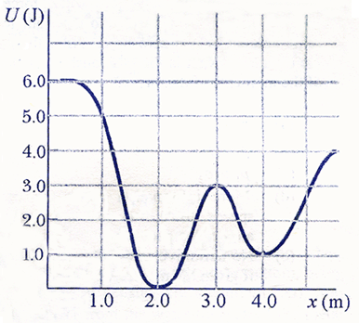

- Choose the x values (intervals) for which the force is positive.

(0 – 2) (2 - 3) (3 – 4) (4 – 5)

- Choose the x values (intervals) for which the force is negative.

(0 – 2) (2 - 3) (3 – 4) (4 – 5)

- For which values of x is the force zero?

- Estimate the value of x for which the force has the largest magnitude?

- If a particle has to reach the 1m location, what minimum total energy must it have?
- Can a particle with total energy 0.9 J reach the point at 4m? Why or why not?

- A particle starts at rest at location 1.5m.
- What is its potential energy?
- What is its total energy?
- Describe the subsequent motion of the particle. In particular, state the location where its has maximum speed and estimate the location when it again is at rest. What is the direction (positive/negative) of the force at this point?

PROBLEM #2:
The potential energy function of a 1kg particle is given by
.

- What is the force F(x) associated with the potential function?

- At what values of x is the force zero?

- What is the total energy of the particle at x = 1m?

- If the particle is released at rest at x = 1m, how fast is it moving at x = 0m?

- Plot U vs x and F vs x in the space below (two separate graphs)
F vs x
U vs x

